

**Sany3y**

***Version 1.0***

|  |  |  |
| --- | --- | --- |
| **ID** | **Name** | **Email** |
| 21030343 | Mohammed Atef | [mohamed45452020@gmail.com](mailto:mohamed45452020@gmail.com) |
| 21060536 | Steven Amin | [stevenameen02@gmail.com](mailto:stevenameen02@gmail.com) |
| 21040560 | Omnia Ashraf | [omniaamohamed102@gmail.com](mailto:omniaamohamed102@gmail.com) |
| 21056226 | Kenzi Shibl | [kebzishibl@gmail.com](mailto:kebzishibl@gmail.com) |

*Nov of 2025*

**Table of Contents**

**Introduction** 3

**Project Planning** 3

Project Objectives 3

Project Scope 3

Assumptions & Constraints 4

Success Criteria 4

**Stakeholder Analysis** 4

Stakeholder List 4

Roles & Responsibilities 4

Stakeholder Needs & Expectations 5

Risks & Mitigation 5

Summary 5

**Database Design** 5

Database Objectives 5

Entities and Attributes 6

Relationships 8

ERD 9

Summary 9

**UI/UX Design** 10

*Special thanks to Eng.* [***Mohammed Bayoumi***](https://www.linkedin.com/in/mohamed-bayoumi-1a3779210) *for his outstanding efforts with us, and for providing valuable information and ideas that contributed to the success of the project.*

**Introduction**

The Sany3y platform is designed to connect customers with qualified technicians (صنايعية) across various service categories. This stakeholder analysis identifies key stakeholders, their roles, interests, influence, expectations, and communication strategies to ensure smooth project execution and long-term success.

**Technologies:**

* **Frontend:** ASP.NET Core MVC, HTML5, CSS3, JavaScript, Bootstrap
* **Additional Frontend Libraries & Plugins:** 
  + **DataTables:** For dynamic and interactive tabular data display
  + **Animation.css:** For smooth and attractive UI animations
  + **Swiper.js:** For responsive sliders and carousels
* **Backend:** C#, ASP.NET Core Web API
* **Real-time Communication:** SignalR for chat and showing if users are online or offline.
* **Database:** SQL Server for structured data storage and management
* **Authentication & Security:** ASP.NET Identity, JWT for secure access
* **Version Control & Collaboration:** Git and GitHub for code management and team collaboration
* **AI-based Feature for National ID Detection:**
  + **FastAPI:** Hosts the AI service.
  + **Functionality:** Automatically detects and reads the national ID number from an uploaded ID card image, helping to verify users quickly and securely.

# **Project Planning**

## Project Objectives

* Provide customers with quick access to trusted technicians.
* Enable technicians to manage their services, schedules, and profiles.
* Offer an easy-to-use admin panel for overseeing platform operations.
* Enhance service quality with ratings, reviews, and automated tracking.

## Project Scope

* Responsive website for customers and technicians.
* Full admin dashboard (web-based).
* Core features: booking, scheduling, technician profiles.
* Notifications (email, in-app).
* Role-based access control.
* Analytics dashboard.

## Assumptions & Constraints

**Assumptions:**

* Stakeholders provide timely feedback.
* Necessary APIs and integrations are available.
* Team members are dedicated and available.

**Constraints:**

* Fixed deadline for launch.
* Budget limitations.
* Third‑party API rate limits.

## Success Criteria

* System launch on time.
* Positive customer feedback.
* Smooth technician onboarding.
* Efficient admin workflow.

# **Stakeholder Analysis**

## Stakeholder List

|  |  |
| --- | --- |
| **Stakeholder** | **Description** |
| Administrators | Manage the platform, users, and system operations. |
| Technicians | Provide services through the platform. |
| Customers | Book services from technicians. |

## Roles & Responsibilities

**Administrators**

* Monitor platform performance
* Manage technicians and customers
* Resolve issues and oversee quality

**Technicians**

* Deliver requested services
* Maintain accurate profiles
* Respond quickly to bookings

**Customers**

* Search for technicians
* Make bookings
* Provide reviews and feedback

## Stakeholder Needs & Expectations

|  |  |
| --- | --- |
| **Stakeholder** | **Description** |
| Administrators | Clear dashboards, stable system. |
| Technicians | More job opportunities, fair visibility |
| Customers | Trusted technicians, fast booking. |

## Risks & Mitigation

|  |  |  |
| --- | --- | --- |
| **Risk** | **Affected Stakeholder** | **Mitigation** |
| Poor service quality | Customers | Rating system + technician verification |
| Low visibility | Technicians | Fair listing algorithm |
| Development delays | Admins | Clear requirements + sprint planning |
| Downtime | All users | Monitoring + backups |
| Payment failures | Customers | Multiple payment options |

## Summary

This simplified and professional stakeholder analysis ensures the Sany3y platform meets user needs while maintaining high quality, strong communication, and efficient operations.

# **Database Design**

## Database Objectives

* Ensure data consistency and integrity.
* Support user, technician, booking, and admin operations.
* Provide efficient querying for dashboard analytics.
* Enable scalable growth for future platform expansion.

## Entities and Attributes

|  |  |  |
| --- | --- | --- |
| **Entity** | **Description** | **Key Attributes** |
| **ProfilePicture** | Stores the paths of users' profile pictures | * ProfilePicID (PK) * ProfilePicPath |
| **Addresses** | Stores address details (street, city, governorate) | * AddressID (PK) * Street * City * Governorate |
| **Categories** | Represents the categories of services or skills in the system | * CategoryID (PK) * Name * Description |
| **Users** | Stores information about system users (clients/technicians) | * UserID (PK) * Email (Unique) * Fname * Lname * Password * PhoneNumber * NationalID * Gender * Username * CreatedAt * ProfilePicID (FK) * AddressID (FK) * CategoryID (FK) |
| **Tasks** | Tasks created between clients and technicians | * TaskID (PK) * Title * Description * Status * CategoryID (FK) * ClientID (FK) * TaskerID (FK) |
| **Notifications** | Notifications sent to users | * NotificationID (PK) * Message * Type * CreatedAt * IsReaded * UserID (FK) |

|  |  |  |
| --- | --- | --- |
| **Messages** | Messages exchanged between clients and technicians | * MessageID (PK) * Content * SentAt * SenderID (FK) * ReceiverID (FK) |
| **Ratings** | Ratings given by clients to technicians after completing tasks | * RatingID (PK) * Score * Comment * TaskID (FK) * ClientID (FK) * TaskerID (FK) |
| **PaymentMethod** | Available payment methods in the system | * PaymentMethodID (PK) * Name * Description * IsActive |
| **Payments** | Records payments related to tasks | * PaymentID (PK) * AmountAgreed * AmountPaid * PaymentDate * PaymentStatus * TaskID (FK) * PaymentMethodID (FK) * ClientID (FK) |
| **Roles** | User roles (Admin / Client / Technician) | * RoleID (PK) * Name * Description |
| **User_Roles** | Many-to-many relationship between users and roles | * RoleID + UserID (Composite PK) * RoleID (FK) * UserID (FK) |
| **TechnicianSchedules** | Schedules for technicians showing availability | * ID (PK) * Date * StartTime * EndDate * IsBooked * TechnicianID (FK) |

## Relationships

|  |  |  |
| --- | --- | --- |
| **Relationship** | **Type** | **Description** |
| **ProfilePicture → Users** | One-to-Many | Each user has one profile picture, but a profile picture could theoretically be linked to multiple users (depending on your design, usually 1-to-1). |
| **Addresses → Users** | One-to-Many | Each user has one address, but an address can belong to multiple users. |
| **Categories → Users** | One-to-Many | Each user belongs to one category (e.g., skill), each category can have many users. |
| **Categories → Tasks** | One-to-Many | Each task belongs to a category; a category can have many tasks. |
| **Users → Tasks (Client)** | One-to-Many | Each client can create many tasks; each task has one client. |
| **Users → Tasks (Tasker/Technician)** | One-to-Many | Each technician can be assigned to many tasks; each task has one technician. |
| **Users → Notifications** | One-to-Many | Each user can receive many notifications. |
| **Users → Messages (Sender)** | One-to-Many | Each user can send many messages. |
| **Users → Messages (Receiver)** | One-to-Many | Each user can receive many messages. |
| **Tasks → Ratings** | One-to-Many | Each task can have ratings. |
| **Users → Ratings (Client)** | One-to-Many | Each client can rate multiple tasks. |
| **Users → Ratings (Tasker)** | One-to-Many | Each technician can be rated multiple times. |
| **PaymentMethod → Payments** | One-to-Many | Each payment method can be used for many payments. |
| **Tasks → Payments** | One-to-Many | Each task can have many payments. |
| **Users → Payments (Client)** | One-to-Many | Each client can make many payments. |
| **Roles → User_Roles** | One-to-Many | Each role can be assigned to many users. |
| **Users → User_Roles** | One-to-Many | Each user can have multiple roles. |
| **Users → TechnicianSchedules** | One-to-Many | Each technician can have multiple schedule entries. |

## ERD

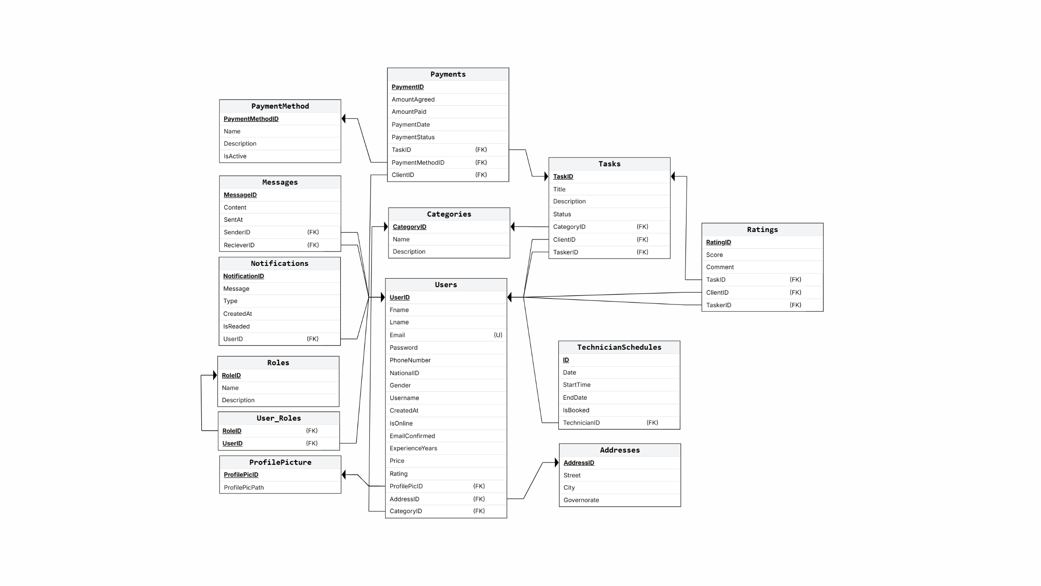

## Summary

This database design supports the core functionalities of the Sany3y platform, ensures data integrity, allows scalability, and maintains efficient query performance.

# **UI/UX Design**

